# DevOps Task 5-: RUNNING GRAFANA AND KUBERNETES ON TOP OF KUBERNETES WITH PERSISTENT STORAGE

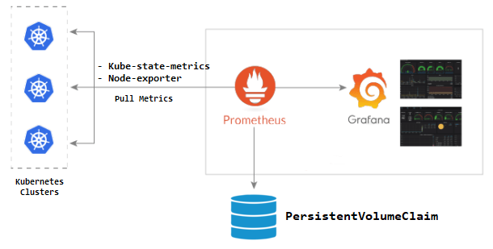

This project makes the data of Prometheus and Grafana Persistent using PVC. In this project, I have created a multi-container pod

in which two pods (Grafana and Prometheus ) have been launched using images pre-uploaded on DOCKER HUB. We can also create

our own image using Dockerfile and the upload it our repository to use it.

Step 1-: Create the folder and save all the following required files for this task.

This file creates a deployment with two containers inside pod using the images.

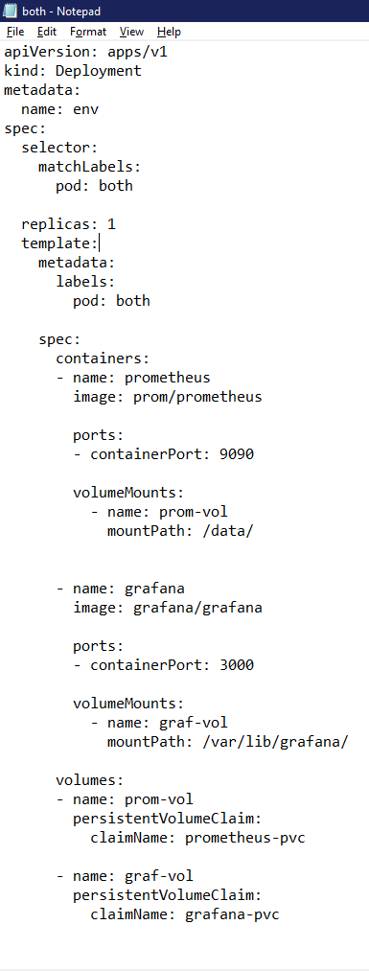

Create PVC files for PVC claims for Grafana.

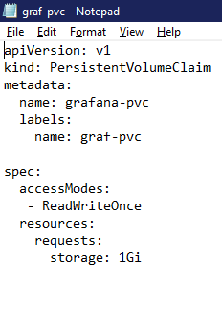

Create PVC files for PVC claims for Prometheus.

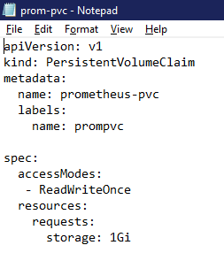

Create a service file two expose both the pods to the outside world.

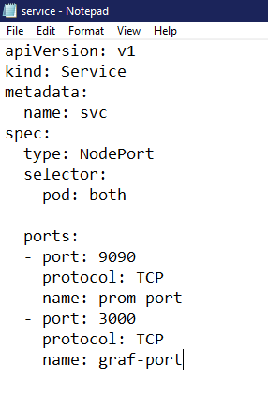

Create a Kustomization file so that all these files can be run using a single command.

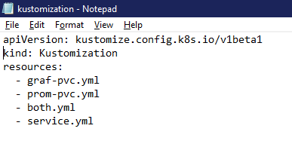

Now, start minikube and run the the command –

**kubectl apply -k .**

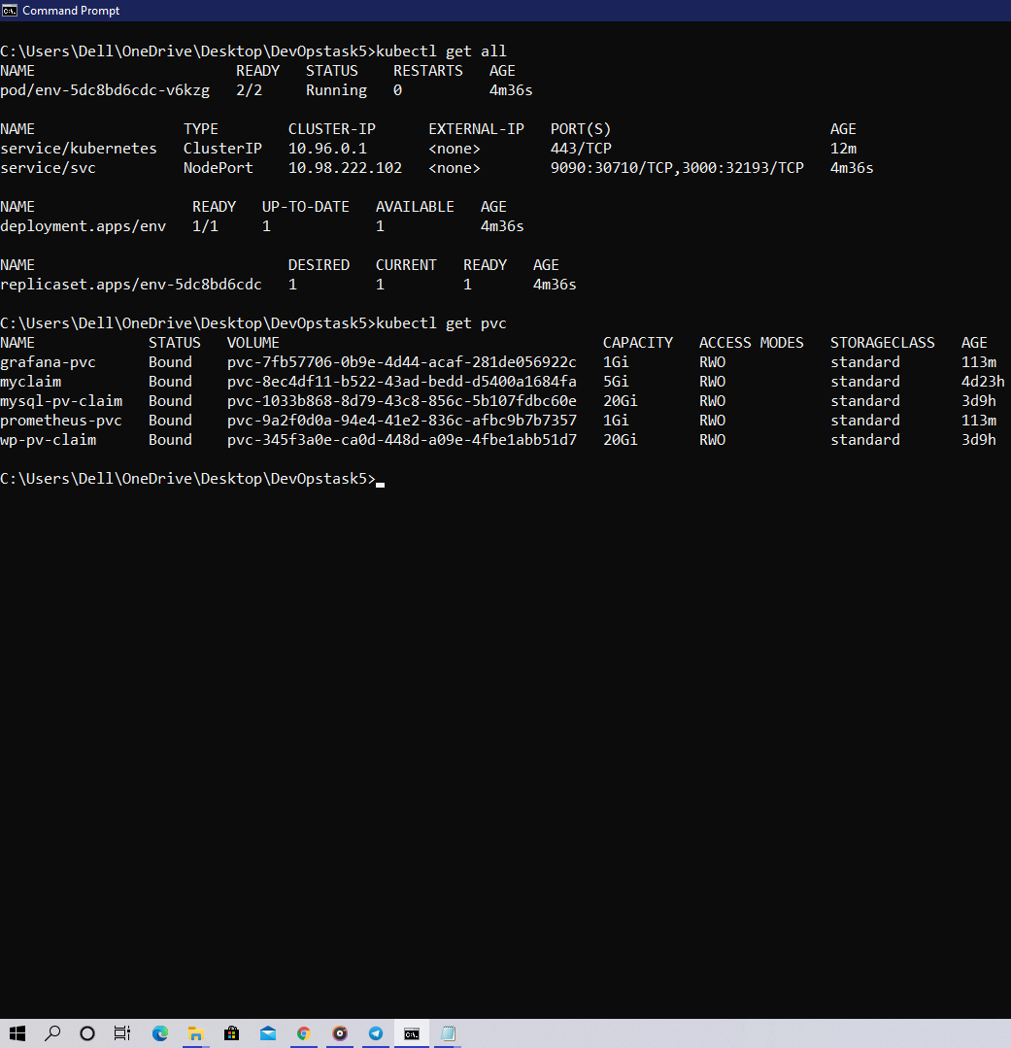

When we run the exposed file we get the following Output.

